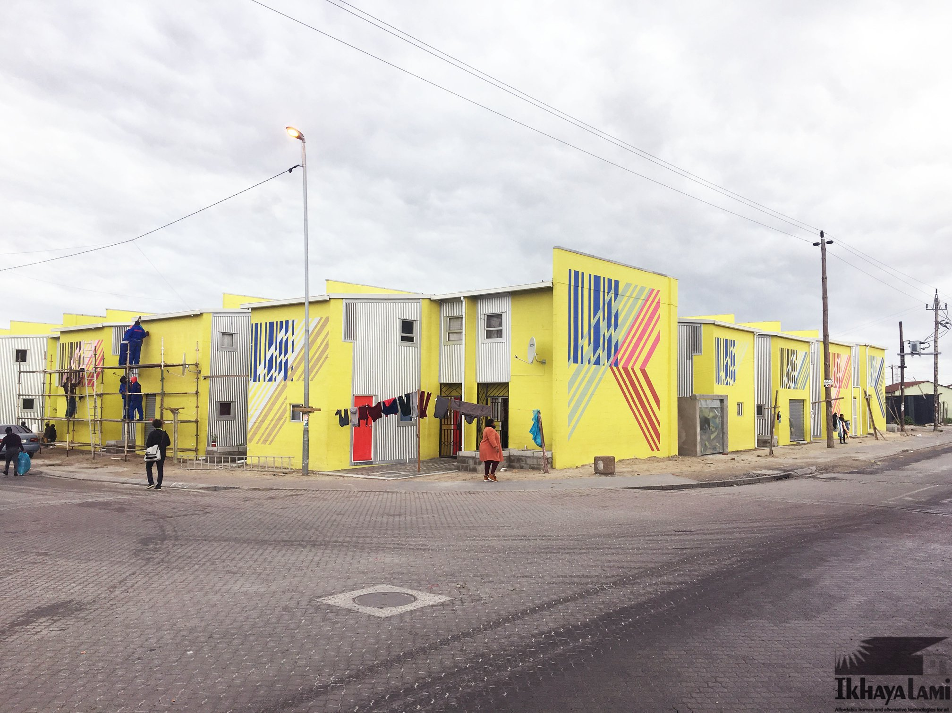

IKHAYALAMI

DEVELOPMENT SERVICES
ANNUAL REPORT 2022
TABLE OF CONTENTS
REMARKS FROM ANDREA BOLNICK 3
PROJECTS OVERVIEW 5
RE-BLOCKING 6
EMPOWERSHACK 8
DISASTER RESPONSE & SOCIAL EMERGENCIES 10
FIRE RETARDANT PAINT PROJECT 12
SHELTER FINANCE 13
THE ACCREDITATION OF INFORMAL CRECHES 14
SAFE SPACES FOR CHILDREN 16
FINANCIAL REVIEW FROM BEN NKUNA 18
ACKNOWLEDGEMENTS 19
OUR PARTNERS AND FUNDERS 20
GET INVOLVED 21

REMARKS FROM ANDREA BOLNICK
MANAGING DIRECTOR
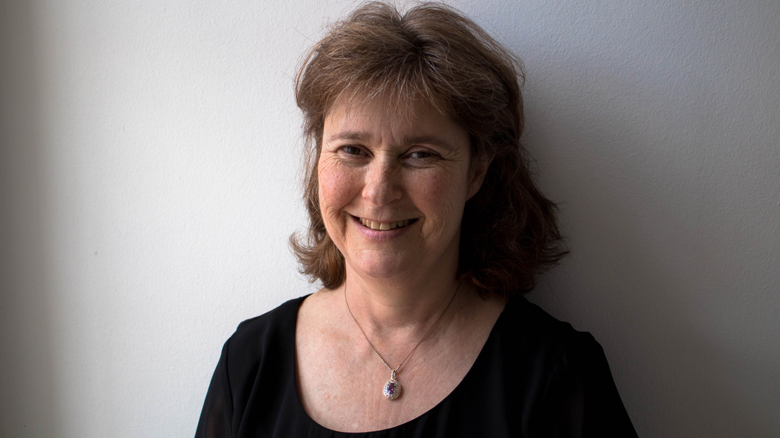
Ikhayalami considers informal settlements as disasters that have been caused by market and policy failure. In spite of the fact that they are tangible expressions of the innovation and resilience of their inhabitants, they remain subject to forced eviction, flooding, the spread of water borne diseases and to runaway fires. The consequence of these threats and actual disasters is acute psychological and material strain on the inhabitants, especially women, children, the disabled and the elderly.
Housing delivery by the state has slowed to a crawl while in-migration and new household formation continues to add tens of thousands of new shack dwellers to the city every year. Ikhayalami therefore redoubled its efforts in 2022 to assist vulnerable households to upgrade their shacks. We continued to improve informal social amenities as well such as creches and safe homes for vulnerable children. We also continued our pro-active work in the reconfiguration of settlement layouts with active participation of communities, leading to easier access for the provision of basic services. These interventions also reduced risks of fire and flooding and created public open spaces. Each and every household was accommodated in the spaces we reconfigured and no one was shifted without their express consent. We improving the lives of over 1500 poor people living in Cape Town’s informal settlements

We remain one of the only Civil Society Organisations in Cape Town who respond to emergency situations, especially shack fires. Our experienced and well-trained build teams were often the first on the scene helping affected households rebuild improved and safer dwellings. This included opening of roads and the application of fire-retardant paints.
Ikhayalami understands the need for poor households to upgrade their dwellings incrementally, often beginning with improvements and extensions to existing informal structures. This certainly does not mean that iKhayalami believes that a better shack is the end of this incremental process. Nothing demonstrates this better than our widely acclaimed “Empowershack” project that we have implemented along with ETH-Zurich. In this project we have now built 48 formal homes where shacks once stood, with the formal structures incorporating many community design principles. We remain involved in this project even though the structures are now complete, assisting in securing and managing solar energy provision through an on-site mini grid. Our ongoing social facilitation in this project enables us to open new opportunities for similar projects in areas where we have done shack improvements in the recent past.
Our shelter finance continues to grow steadily, with over 50 shack upgrades having been provided, including a growing number in which private individuals have made financial contributions or stood surety for loans for their employees. This innovative programme was submitted as a candidate to the SAB Foundation’s Social Innovations Award. We are delighted to announce that we placed second in this competition (first in the urban context) and walked away with a generous prize and with great opportunities for networking and for organizational development.

PROJECTS OVERVIEW

Reblocking Empowershack Disaster Response
11
Settlements
1
Settlements
2
Settlements

258
People Impacted
59
People Impacted
214
People Impacted

73
Homes Built
20
Homes Built
80
Homes Built

_________________________________________________________________________
Social Emergency Fire Retardant Shack Painting Shelter Finance
18
Homes Built
49
People Impacted
18
Families
2
Settlements
7
Families
74
Homes Painted
231
People Impacted
7
Homes Built
21
People Impacted

__________________________________________________________________________________
Creches

2
Creches Built
200
Children Impacted
2
Settlements

re-blocking

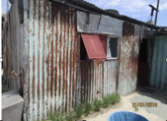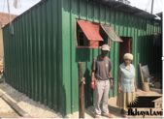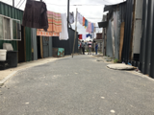
Re-blocking describes a design and implementation process that is driven by the community. It involves the reconfiguration of a settlement layout into one that is more formalized and standardised. This allows for the creation of demarcated pathways or roads, public and semipublic spaces - all of which open access for emergency vehicles and the provision of infrastructure and basic services. Ikhayalami’s re-blocking methodology is predicated on the grounds that urban poor communities should, at all times be active agents in the forefront of development of the areas in which they reside. By including the urban poor as partners rather than imposing external solutions on them, local authorities and other regulatory bodies can be much more effective than they are at present in terms of redesigning informal settlement layouts, and enabling incremental upgrading of informal housing and infrastructure. At the same time poor communities can challenge spatial divisions, secure external funding, especially state resources and become recognized citizens in the cities in which they live.
Ikhayalami has two approaches to re-blocking: reactive and pro-active. After a fire or other disaster Ikhayalami will work with the affected communities to rebuild the area in a re-blocked configuration. The pro-active re-blocking approach encompasses in-situ rebuilding of shacks, in which shacks will get dismantled and new upgraded fire and flood resistant shelters then get erected in a reconfigured layout.
In 2019 Ikhayalami received funding from Selavip and the Charles & Lynn Schusterman Family Foundation to implement and complete two re-blocking projects. Funding from the Schusterman Foundation was raised with the help of the Mensch Network under a partnership with Ikhayalami that has been named Project Bayit. Through Project Bayit, the remaining 26 shacks in AT Section, Khayelitsha were re-blocked. This follows on from 2018 when Selavip funded the re-blocking and building of 88 Ikhayalami prototype shelters in a reconfigured layout in AT Section. AT section comprises 114 households- now all re-blocked.
Selavip also funded the re-blocking of 54 shacks in Nyebelele in Site C in Khayelitsha, as part of another settlement wide re-blocking project. 19 shacks still remain to be upgraded.
Enumerations were conducted and relevant data was collected in both settlements order to understand the socio economic realities of the people who have lived in these settlements for decades. Based on these learnings a total of 80 shelters were rebuilt with our fire and flood resistant material, creating safer and larger homes, demarcated pathways and open public and semi-public spaces. In the two settlements the living conditions of 214 people have been vastly improved.
Nyebelele settlement: with Re-blocking comes incremental housing improvement

EMPOWERSHACK

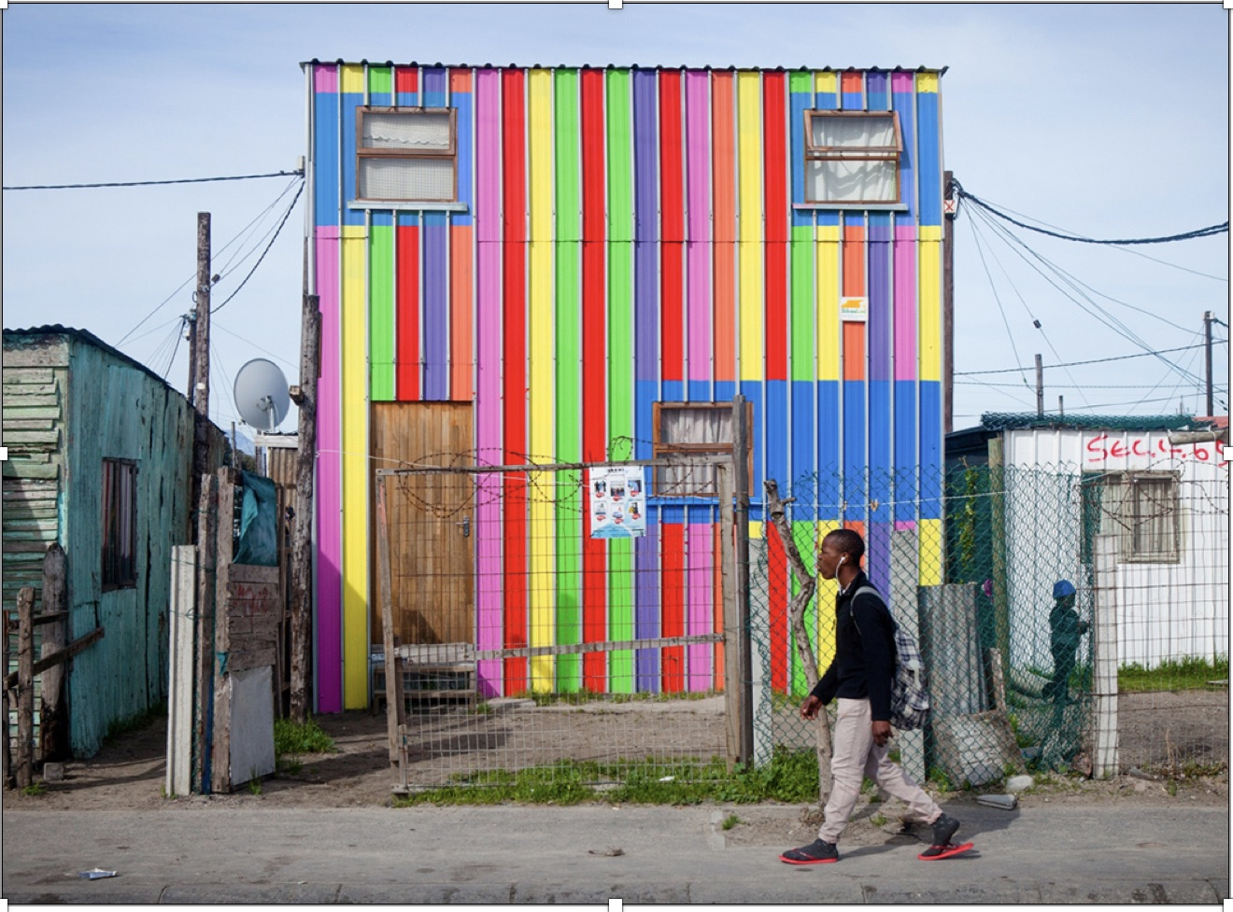

The release of the Municipal Economic Review and Outlook (Mero) report in June
2018 painted a bleak picture of an ever-growing housing crisis in Cape Town. The estimated housing backlog stood at 255,000 units and it has certainly grown since then. The Mayoral Committee Member for Human Settlements, Malusi Booi, made a pertinent statement: “To tackle the requirements of high urbanisation, we are all going to have to start standing together. This is not a municipal issue alone. It involves all levels of government and the society as a whole,”
The role of Ikhayalami is not to build thousands and thousands of tiny houses on the outskirts of Cape Town. Rather its value proposition is to use its nimbleness, its capacity and experience to set precedents that demonstrate to the Government and to other stakeholders how the challenge can be addressed more effectively. For iKhayalami this means more than timescales and timeframes. Ikhayalami’s precedent-setting interventions give equal attention to the quality and the affordability of these projects - for both the City and for the households who are affected.
The Empowershack project has aimed to reshape the current dysfunctional approach to informal settlement upgrading by offering an innovative and inclusive methodology. Our approach aims to distribute public space more equitably in the settlement and in the city. The same applies to the delivery of basic services.
The Empowershack is an urbanization scheme that combines incremental housing upgrade with a safer urban environment that offers its inhabitants new economic and social possibilities Structured community workshops, enumerations, affordability assessments and microfinance contracts have provided the framework for the upgrading of 72 existing single storey shacks to double storey housing units. The resulting densification has produced efficient land use to infrastructure ratios, while guarantee-ing that all residents remain on the site. Additionally, the readjusted building stock, new land plot sizes and allocation of public space have been designed to integrate with municipal planning frameworks.
Ikhayalami has provided the interface between government and the community and has ensured that the community provided a high level of input into the design of the housing prototypes and the urban layout and are at forefront of all aspects of the development. Ikhayalami has facilitated this process throughout and will continue doing this in phases 3 and 4. It is anticipated that the project will succeed in a policy shift in terms of tenure security for a higher density development within governments low cost housing arena.
In 2019, Ikhayalami and its partners, Urban Think Tank and the BT Community itself were able to finalise the second phase of the Empowershack project with the construction of 22 double-storey houses. The total number of households in BT is 72. Phase 3 and 4 comprise of respectively 33 housing units incorporating the potential for rental/retail space and 7 housing units for rental or sale.

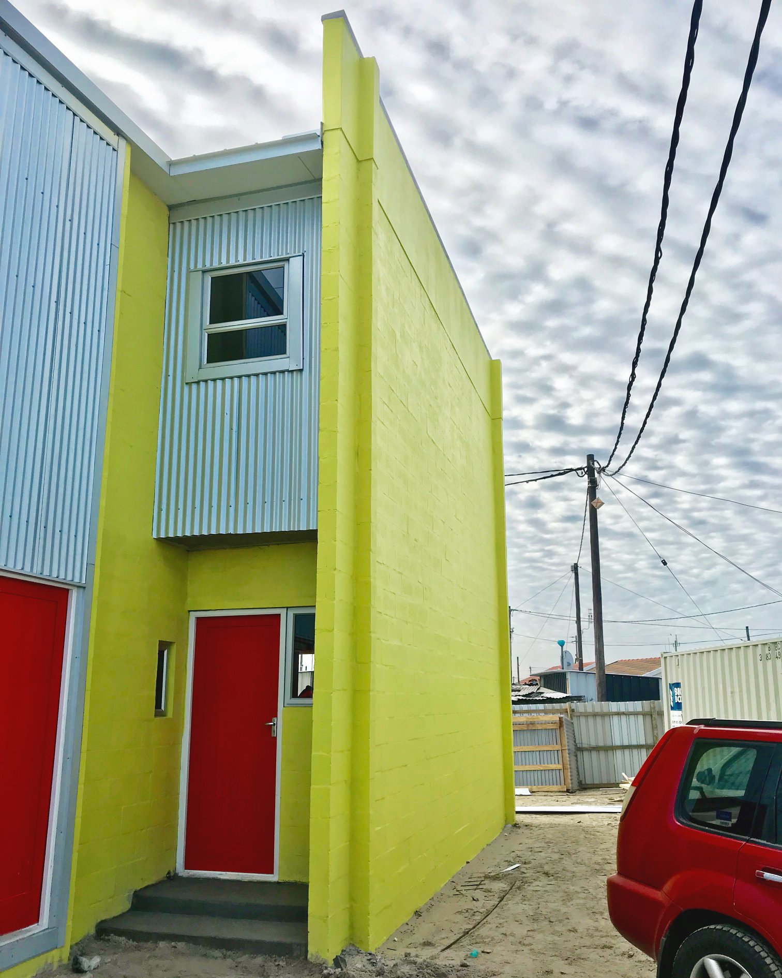

DISASTER RESPONSE & SOCIAL EMERGENCIES

Every year the Ikhayalami team has witnessed first-hand the utter devastation caused by shack fires and by flooding after heavy rains. Our state of readiness to respond to such disasters is without parallel. This is because our extensive experience has taught us what needs to be done, what needs to be provided and what needs to be negotiated in such situations. Over and above such practicalities is a raw, emotional understanding based on what we have witnessed over and over again when the flames bring death and destruction and when the flood waters sweep away or destroy belongings, livelihoods and lives. This appreciation of the devastation caused by fire and flooding remains a principle motivator of all our efforts.
Ikhayalami has now designed an improved shelter that is fire and flood resistant, easy to transport, quick to build, durable, strong and affordable. We have coupled this with, where ever possible, the ability to assist communities in the redesign of a reconfigured layout so as to further mitigate the likelihood of future natural disasters. We use our longstanding links to City and Provincial Governments to try and improve their own reactive and pro-active responses.
In 2019 through the generous funding provided by the Gerald Fox Foundation and the Sisters of the Holy Family, Ikhayalami was able to respond to 13 instances of shack fires in 11 different settlements and offer immediate relief to 73 households.
Ikhayalami always responds to calls it receives from the affected communities themselves. In particular we work closely with Sikhona Nathi, a social movement in the Western Cape. When we have available funding our community facilitators and technical team visit the site, assess the situation and engage with the affected residents. When they are keen to work with Ikhayalami to reconfigure their sites we initiate participatory planning processes. We provide material and technical know-how to help the residents redesign their homes and rebuild new fire and flood resistant shelters without any undue delay.
Ikhayalami also responds to what we regard as social emergencies. Families living in deplorable conditions are regularly brought to our attention. They are normally referred to us by community-based organisations. We then vet them and once approved we build them a new fire and flood resistant home. These upgrades vastly improve the quality of life for the occupants.
In 2019 through funds received from the Percy Fox Foundation Ikhayalami was able to assist seven families who previously lived in dire living conditions. A shortage of funds meant that we had no choice but to turn away many more families living in very poor conditions.

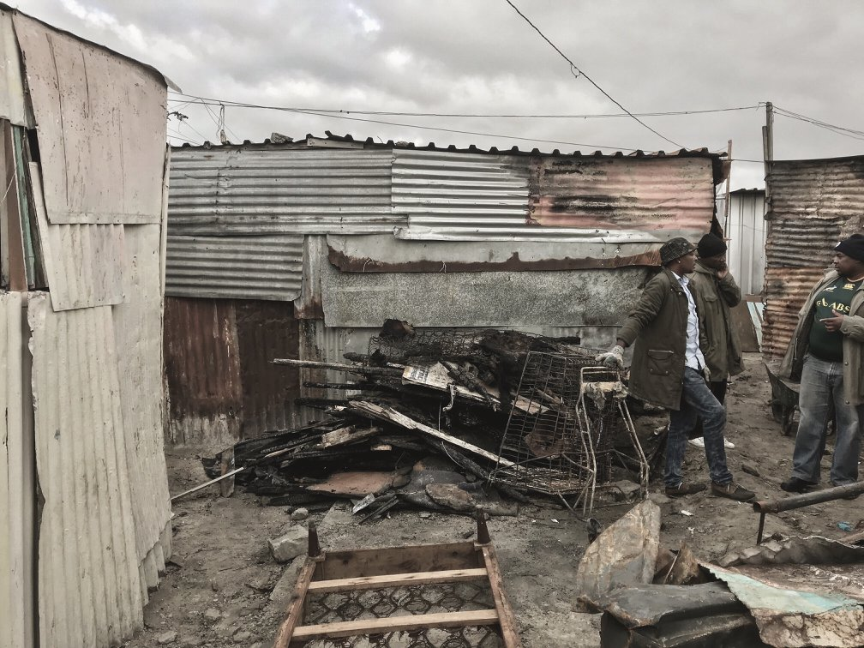

FIRE RETARDANT PAINT PROJECT
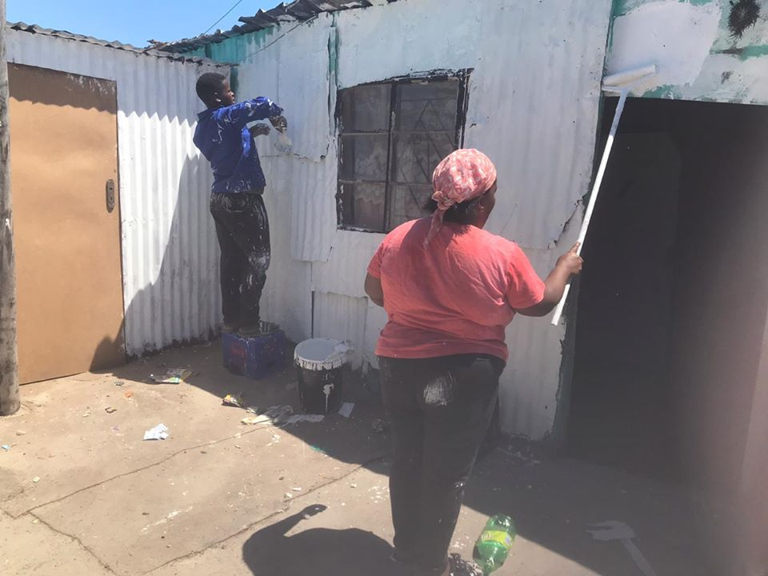
In order to prevent future fires Ikhayalami launched a fire retardant paint project in 2019. We used paint as a preventative measure in two settlements. Both have been plagued by multiple shack fires in the past. They are BT500 and Nyebelele B informal settlements. BT500 consists of 50 households and Nyebelele B has 24. With help from the community itself, Ikhayalami painted all houses within three days. Painting shacks with fire retardant paint works best if every shack in the same vicinity is painted. In order to ensure this is we painted every shack in these two settlements. Funding for this initiative was provided by the Sisters of the Holy Family.

SHELTER FINANCE
There is an enormous demand from individual households for finance needed to upgrade shacks. There is also huge community demand for improved and safer soup kitchens, crèches, and houses of worship in informal settlements. Most formal financial institutions regard this “sector of the market” as being too risky. Those that do offer credit charge exorbitant rates of interest.
Ikhayalami’s familiarity with the communities in which we work, combined with our collective experience in micro-savings and micro-credit, gave us the confidence to launch a loan finance programme in 2014. Since then we have been able to develop a mechanism that provides access to credit for households and/or organisations that want to purchase our products directly. Through Ikhayalami’s loan financing scheme, 17 local households contributed a total of ZAR 197.232,00 to their structures in 2019. That represents a 90%+ repayment rate. An amount of ZAR 117.268,00 is still out on loan.
Ikhayalami has built on this success in a highly innovative way. In late 2019, in partnership with the Mensch Network and the Charles and Lynn Schustermann Family Foundation we launched Project Bayit. This project offers employers an opportunity to contribute to an upgraded shelter for their employees. Ikhayalami provides pre-finance for the build and the employer guarantees the loan and takes on the responsibility for repayment. iKhayalami completed the first build in December 2019, and will continue to champion this cause. It is a simple and effective way in which to facilitate resource flows from the more affluent to the poorer people in our society. Given South Africa‘s (especially Cape Town’s) racial polarization along class lines this initiative opens up one small avenue for cross subsidization as a form of economic redress for historical exclusion and exploitation.

THE ACCREDITATION OF INFORMAL CRECHES
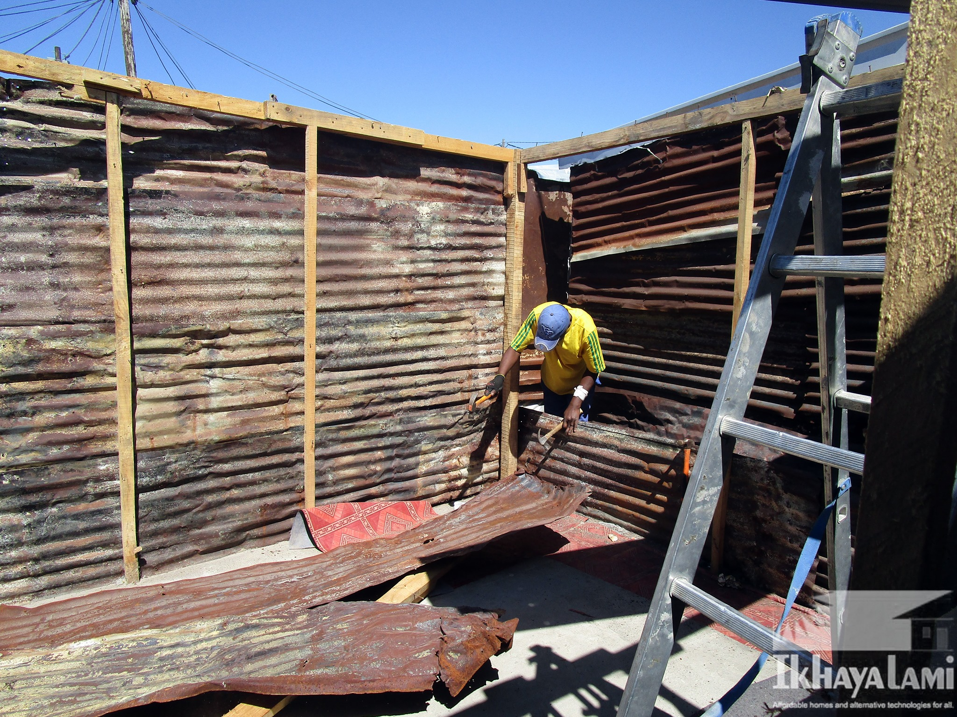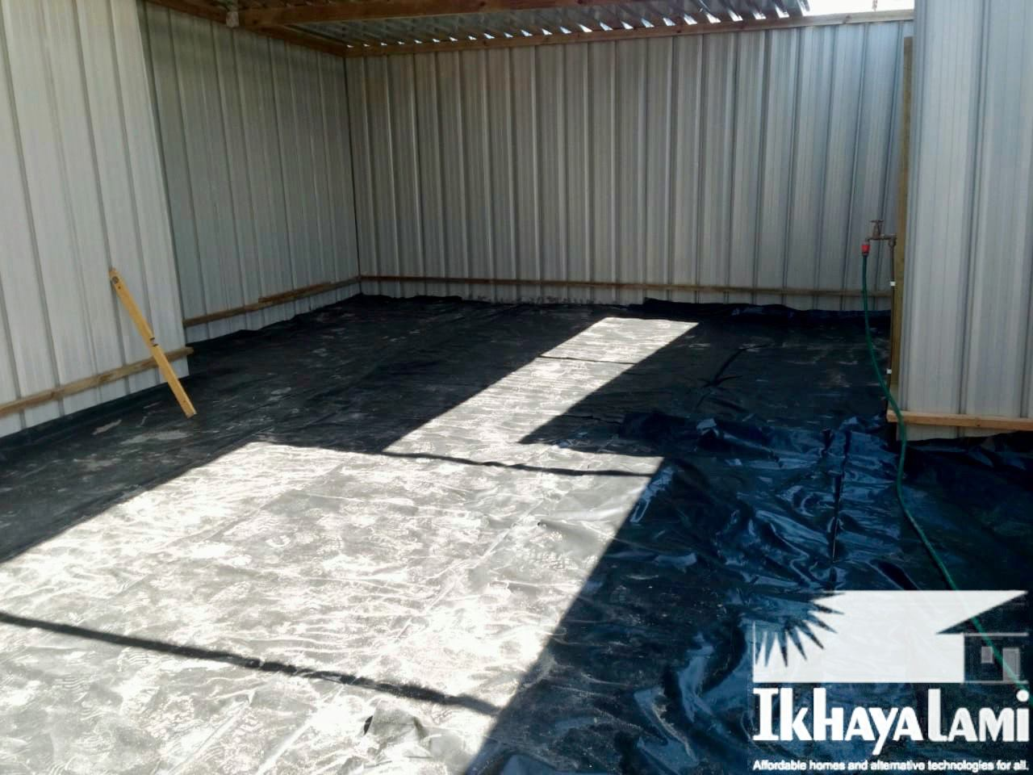
Before After

Ikhayalami has been building creches in informal settlements since 2006. Over the past 14 years we have upgraded over 60 creches using our fire and flood resistant prototype methodology.
The South African Government has a grant programme for formally structured and registered creches. In terms of this grant the state subsidizes the early learning of young children from low-income families. The state has now extended this grant to incorporate informal dwellings, but the catch is that regulations around land tenure and building codes have not been relaxed making compliance almost impossible.
Throughout 2018 and 2019 Ikhayalami worked steadily to design and find a way of building creches that can be accredited. To this end we have been working on two separate fronts with two well respected partners - Arup and Marley Building Systems.
Arup is a multinational professional services firm which provides engineering, architecture, design, planning, project management and consulting services for all aspects of the built environment. Marley Building Systems is a leading international supplier of affordable and sustainable dry construction materials that meet environmentally friendly building requirements.

With Arup we have been conducting research to establish what is needed to make the Ikhayalami creche prototype compliant. Part of this research has been to identify which departments of Government need to be engaged and to demonstrate, through stringent fire tests, that our prototype meets the norms and standards that have been set.
With Marley Building Systems we are further along the road as they have already designed an eco-smart compliant house that Ikhayalami has repositioned as a creche. The long term aim of the partnership is to set up a production facility in Cape Town to build such creches for the informal sector. To this end in 2019 we have built two creches - one in Delft for Blessings Educare Centre and the other in Ndlovini in Khayelitsha for Little Leaders Educare Centre.

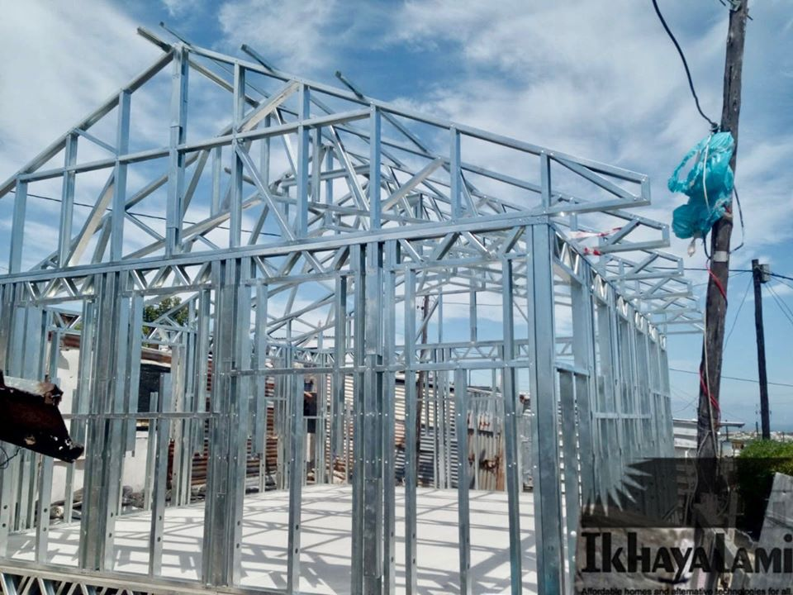

SAFE SPACES FOR CHILDREN

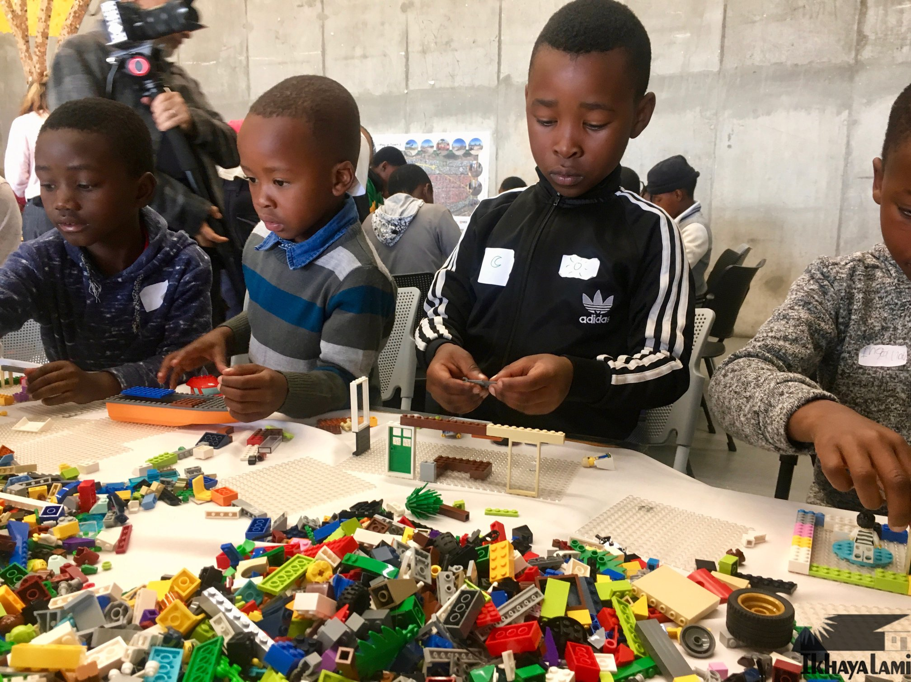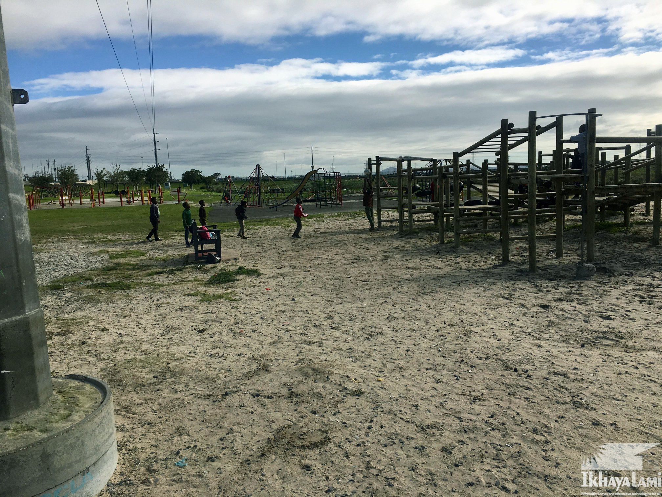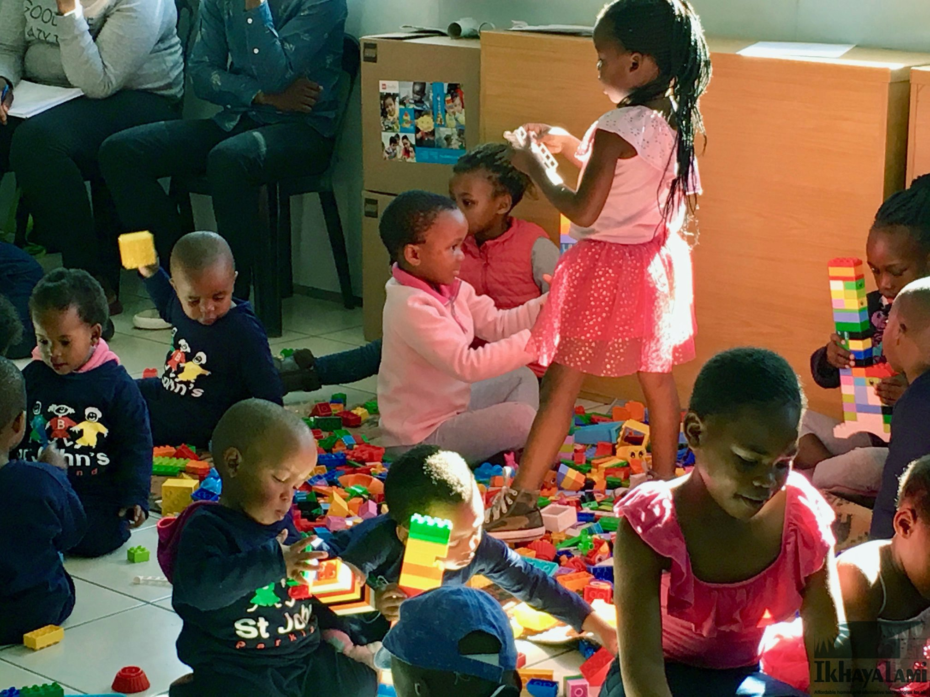

The very earliest years of life are key to fulfilled, productive and meaningful lives. Children's brain and physical development is at its most rapid during these first years as they develop skills and capabilities that affect lifetime outcomes For many children growing up in informal settlements, these earliest years don't offer conditions that are sufficient to reach their developmental potential. Unstimulating environments contribute to children falling short developmentally.
Ikhayalami has been drawn into the research, design and implementation of an exciting play activation initiative for children. We are working in partnership with Arup who have secured the backing of the Lego Foundation. This initiative is part of a broader programme developed by Arup in collaboration with the Real Play Coalition. Its aim is to identify and create safe spaces for children as an important means of enhancing learning and development.
The settlement where this initiative is taking place is in Town II in Khayelitsha, a neighbourhood that became part of our disaster response efforts in 2018 and 2019 following a devastating fire that destroyed 340 shacks. The people in the settlement have felt abandoned since very little has been done to improve their conditions. Ikhayalami has been one of very few organisations that have remained active in the area. When this project was conceptualized Ikhayalami went immediately to Town II. The community welcomed this initiative and have been working closely with the Ikhayalami team who have been facilitating engagements with all stake holders including city officials.

The focus thus far has been on research and design. Early in 2020 we will begin practical implementation. The research component included conducting surveys, mapping the area that was affected by the fire, anecdotal interviews, meetings with settlement leaders and with local authorities. Ikhayalami helped facilitate two design workshops with children from ages 0 - 6 years and 6 years - 12 years. These engagements were both exhilarating and disturbing. It was exhilarating because of the children's enthusiasm and their wonderful ideas but disturbing because of the total lack of spaces and opportunities to play and in the process to learn and to develop. The workshops gave the children and their caregivers an opportunity to have fun, and at the same time to re-imagine the type of safe play spaces they would like to have.
We are excited that in 2020 as part of this Play Activation Initiative we will be creating 6 safe outdoor play spaces for children - 4 in courtyards that were created by Ikhayalami’s re-blocking initiative in the settlement and 2 in areas that children already use as a play area – a derelict and unused play park that we intend to revitalize by restoring the open space and by relocating and upgrading an informal creche that was severely affected by the fire.

FINANCIAL REVIEW FROM BEN NKUNA
CHIEF FINANCIAL OFFICER

acknowledgements

2019 was a very productive year for Ikhayalami. We had a direct and positive impact on the lives of 1,032 households in 14 informal settlements across Cape Town. We are a small team, often under-resourced but what we lack in numbers and finance we make up with dedication, commitment and hard work. We are living proof of the assertion that grassroots participation and smart professional support produce significantly more per dollar spent than most other development institutions, especially governments and bi-lateral and multi-lateral agencies. Their task is to create an enabling policy environment and provide funds for poverty eradication as close to community structures as possible.
Ikhayalami is not a lobbying agency but our practical interventions at project level have had an impact on policy in the past and will do so in the future. In 2013 our endeavors brought re-blocking to the attention of the local authorities in Cape Town, although their policy formulation and adaptation of our bottom-up methodology has resulted in much that is problematic. We hope that our current work with the Empowershack will contribute towards diversified housing typologies and much needed densification.
None of this could have happened without the support of our sponsors and partners. We are grateful for the continued support from the Percy Fox Foundation and Selavip, both of whom have been funding Ikhayalami since 2006. We welcome the Sisters of the Holy Family, Marley Building Systems and the Charles and Lynn Schusterman Family Foundation. They have recently joined us in our efforts to help alleviate the plight of the urban poor and improve their living conditions on the ground where it really makes a difference and by extension in policy deliberations where decisions and decisive action by others can enable replication at scale.
Most important are the communities themselves – the individual households and the community leaders. Their unsung contributions in terms of effort and impact are the foundations upon which all our interventions have been built.

OUR PARTNERS AND FUNDERS

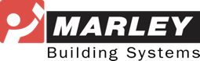

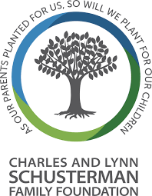

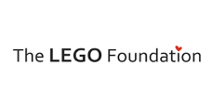
Percy Fox Foundation

GET involved

There are a number of ways to keep abreast of our work.

DONATE
Visit our website at www.ikhayalami.org to make a donation.

FACEBOOK
Visit our facebook page for news and stories.

TWITTER
Follow us on Twitter for short sharp updates @IkhayalamiSA

INSTAGRAM
Find us on Instagram for photos taken at our projects

